Downtown Freeport 2022 Survey Responses
103 Responses between 3/17/22-4/1/22

- Zip Codes Represented
  - Freeport – 85
  - Pearl City – 5
  - Ridott – 2
  - German Valley – 2
  - Baileyville – 2
  - Cedarville - 2
  - Rock City - 2
  - Lena – 1
  - Roscoe -1
  - Dixon – 1

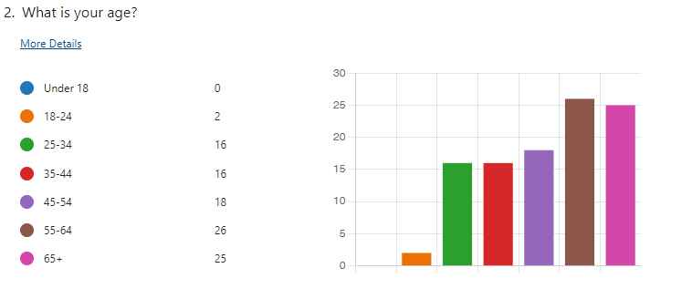
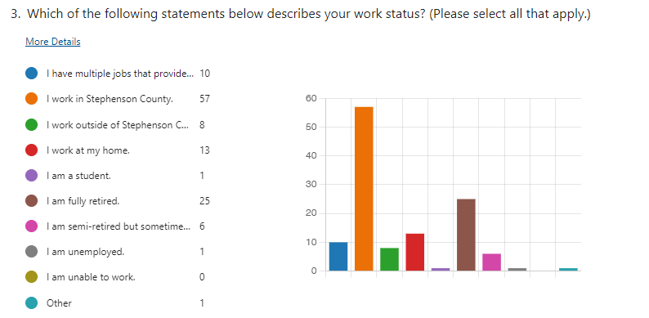

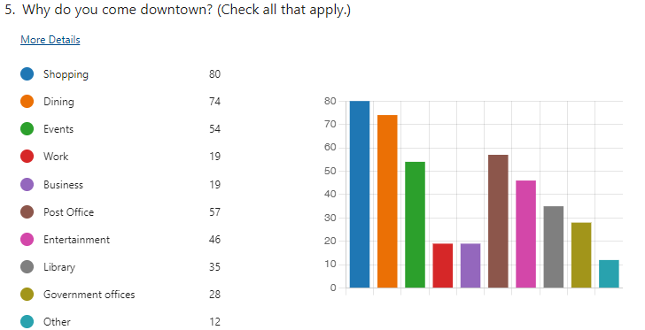

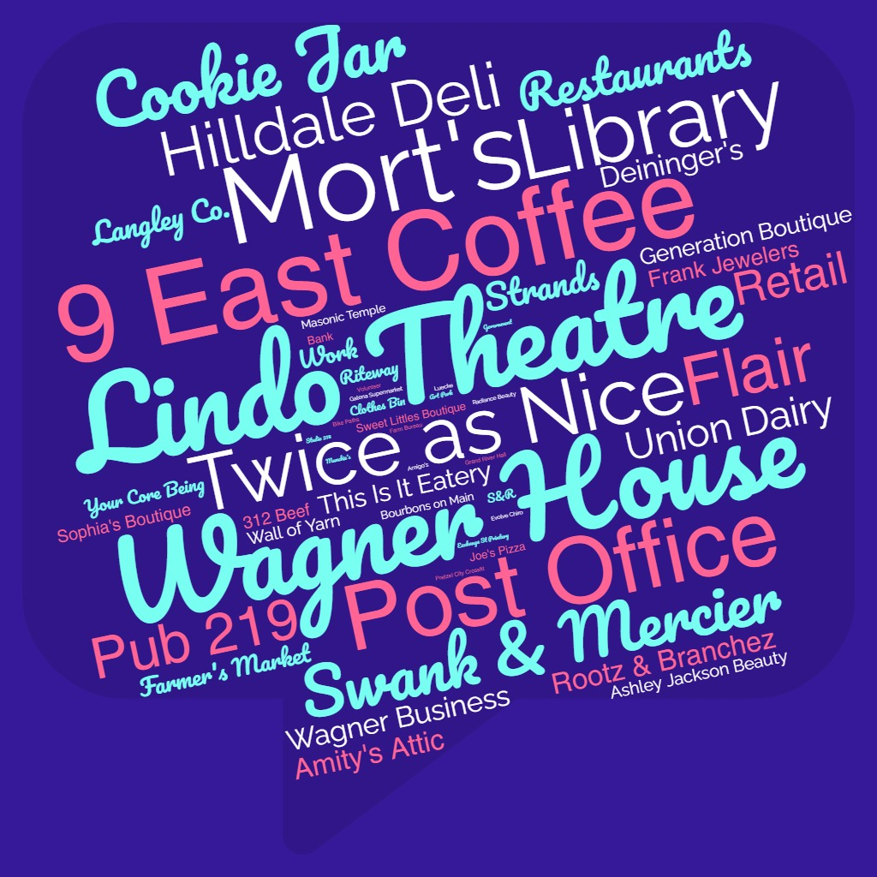
6. What downtown locations do you visit most frequently?

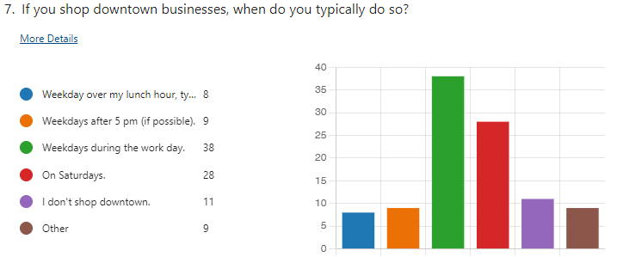

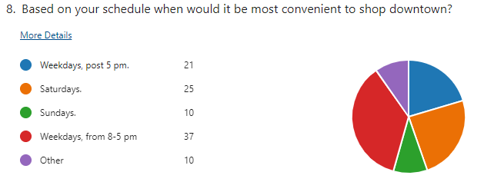

9. What do you shop for most frequently in downtown? (comment box)

Clothing – 44
Food – 22
Household/Furniture – 16
Specialty/Gifts – 15
Jewelry – 9
Services - 8
Office Supplies– 6
Cookies – 5
Farmer’s Market – 4
Beauty – 3
Flowers – 2

10. What types of shops, businesses and/or activities would you like to see downtown? (select up to 3)

Clothing – 51
Antiques – 16
Health & Beauty - 6
Electronics – 5
Jewelry – 4
Lodging – 4

Bookstore – 34
Coffee Shop or Bakery - 34
Pub or Restaurant – 33
Home Goods – 29
Fine Dining – 28
Shoe store - 27
Arts & Crafts – 25
Brewery – 25
Entertainment - 22
Children’s or kids store – 20
Drug Store or pharmacy- 18
Sporting or outdoors - 18
Grocery - 16

11. What would you like to shop for downtown that you currently cannot buy downtown? (comment box)

12. Comments

